KENDRIYA VIDYALAYA SEC 24 NOIDA
SHINING STARS
SCHOOL TOPPERS
CLASS XII AISSCE
- SAMYUKTA SUNDRAM (SCI) SH-I 96.2% FULL MARKS IN BIOLOGY 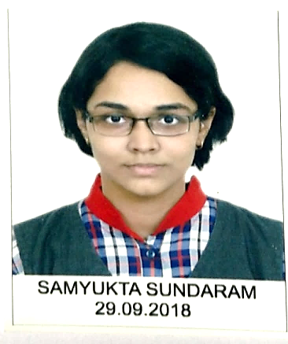
- SHRUTI GOENKA (COMM) SH-I 94.8 %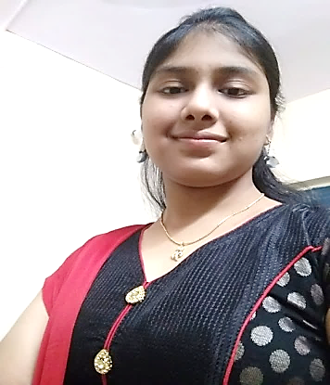 1ST position in National letter writing competition “DHAI AAKHAR—LETTER TO BAPU” organized by Department of post, Ministry of Communication, Government of India.
Conferred the Title “PATRON OF POST” Cash Prize- Rs25000 at State Level and Rs50000 at National Level.

- SAHIL MAHTO (SCI) SH-I 94.4%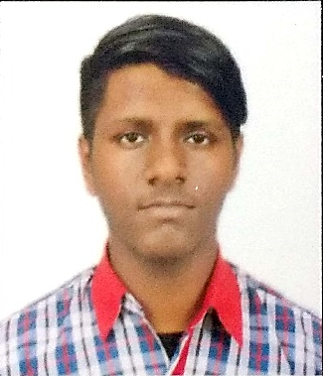

CLASS X AISSE
- SEHAL SAXENA (SH-I) 98.4% FULL MARKS IN ENGLISH & SO. SCIENCE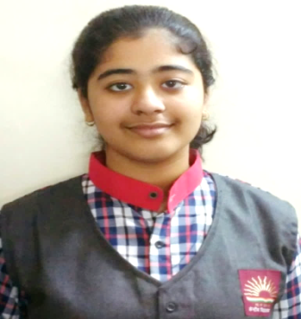
1ST Position in ELOCUTION COMPETITION organized by PUNJAB NATIONAL BANK as part of Vigilance Awareness Week.
- SUHANI SHRIVASTAV (SH-I) 97.4% FULL MARKS IN HINDI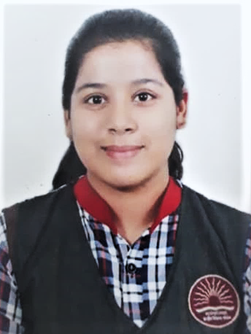
- MITALI SACHAN (SH-I) FULL MARKS IN SANSKRIT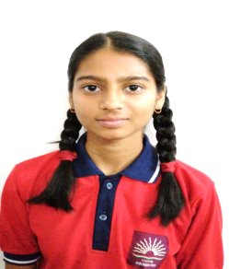
- ANUPAMA YADAV (SH-I) FULL MARKS INHINDI 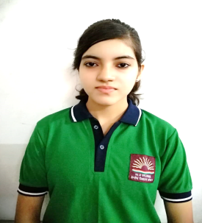
1ST Position in DEBATE COMPETITION organized by INDIAN OIL CORPORATION LIMITED as part of Vigilance Awareness Week.

- CHANDSI (SH-I) FULL MARKS IN SOCIAL SCIENCE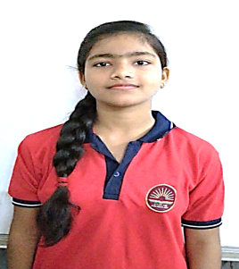

OTHER ACHIEVEMENTS
SHIVAM SINGH (SH- I):- Zonal Rank 2 at IMO.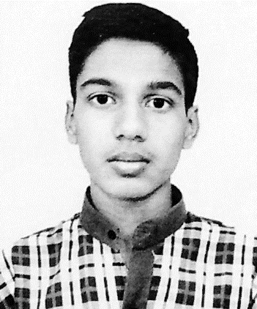
Silver Medal & Cash Prize of Rs. 2500/-
ISH GUPTA (SH-I):- Member of Team from KVS for SAKURA STUDENT EXCHANGE PROGRAM to JAPAN.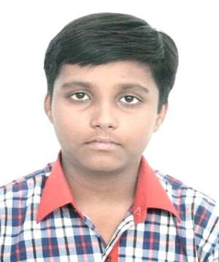
AMEER HAMZAH (SH-I):- Selected by Goethe Institut and Pasch for Youth course to GERMANY from 2nd June to 22nd June.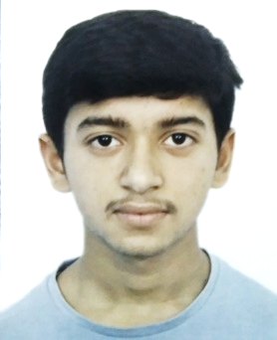
SAHIL(SH-I): Selected For Nationals in JNNSMEE.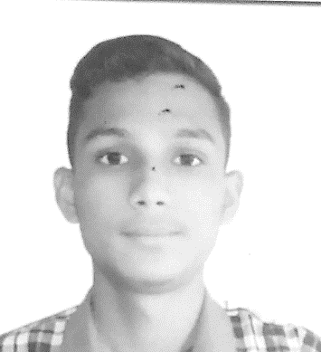

SPORTS STARS:
- VAISHNAVE(SH-I)GOLD Medal in TAEKWONDO (U- 17) in KVS NATIONAL SPORTS MEET. Selected for SGFI 2019-20
- MD. FAIZ(SH-I) – SILVER Medal in Boxing in KVS NATIONAL SPORTS MEET 2019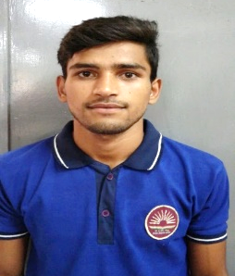
- KRISHNA(SH-I) – SILVER Medal in Taekwondo in KVS NATIONAL SPORTS MEET2019-20.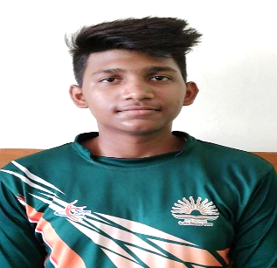
- MOHIKA(SH-I) – BRONZE Medal in Archery in KVS NATIONAL SPORTS MEET 2019-20.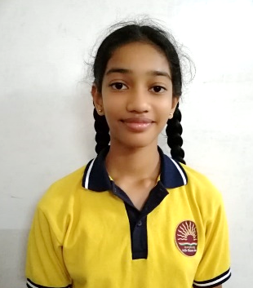
- AHSUN(SH-I) – BRONZE Medal in Rope Skipping in KVS NATIONAL SPORTS MEET 2019-20.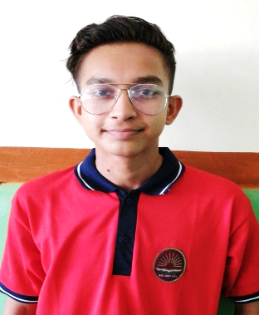
- ANURAG(SH-I) – BRONZE Medal in Rope Skipping in KVS NATIONAL SPORTS MEET 2019-20.