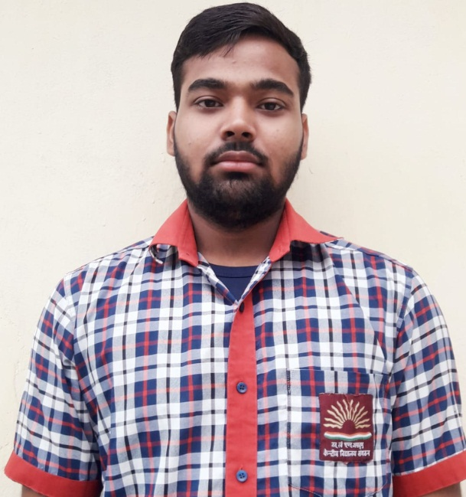
SIDDHARTH GAUTAM,XII B(FIRST SHIFT)CLEARED JEE ADVANCE

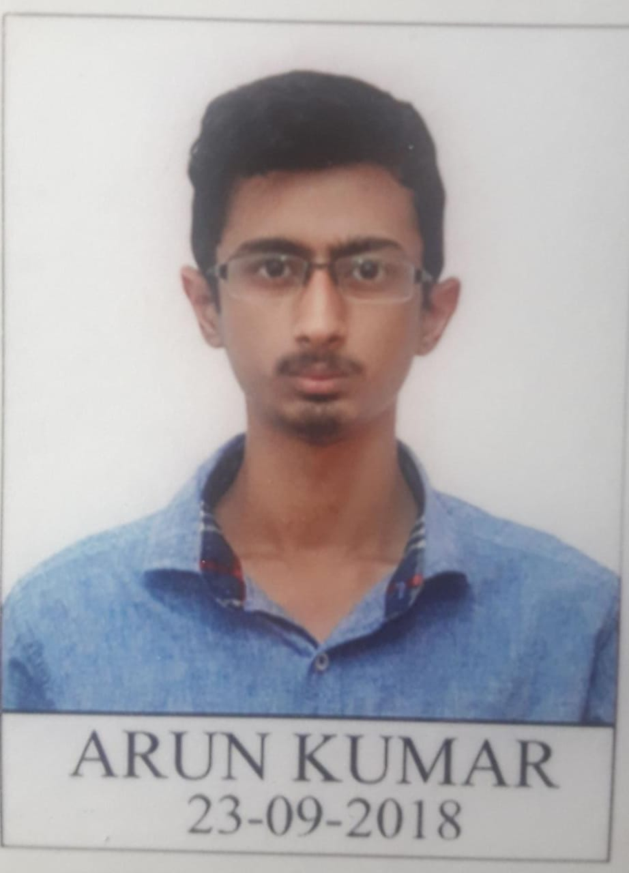
ARUN KUMAR,XII B(FIRST SHIFT)CLEARED JEE ADVANCE

