KENDRIYA VIDYALAYA NOIDA SHIFT-1
AUTUMN BREAK HOMEWORK
W.E.F 20-10-23 TO 29-10-23
CLASS:1
HINDI
1 प्रतिदिन एक पेज सुलेख लिखें।
2 कक्षा में पढ़ाए गए सभी पाठों को पुनः पढ़ें और कविताएं याद करें।
3 अपनी पसंद की कोई भी एक शिक्षाप्रद कहानी रोज पढ़ें।
4 अपना नाम, पिता का नाम माता का नाम और विद्यालय का नाम हिंदी में लिखने का अभ्यास करें।
ENGLISH
1. Revise all written work done in English classwork copy till now.
2.Do one page writing in English Cursive writing book daily.
3. Inculcate reading habits and read good story book from Panchatantra, moral value based etc.
4. Encourage your children to converse in English.
5.Learn school pledge and good five thoughts of great personalities.
6. Make a word chain of 20 words e.g., balloon- nest- temple ....... and so on.
7. Write 15 opposite words other than those done in class work copy. PROJECT WORK: Make a working model of day of week (link is given below): https://youtube.com/shorts/-d3lER0yb74?si=iv10EJwGqQsgmVsv
MATH
1. Write number names 1-30 .
2. Make one dice with dots.
3. Make one A4 size card with 10 dots.
4. Make a model of abacus.
5. Make a model of counting the dots n match
https://youtube.com/shorts/67vdQoHvUZ4?si=OY-dzQ7_3VolvSeC
PROJECT WORK: Make a model of a clock.
EVS
1. Write ten names each of WILD, DOMESTIC, WATER Animals.
2. Write any three lines about our national animal –TIGER.
3. Paste 5-5 pictures of wild and Domestic animals.
4. Paste any 5 leaves and write their names also. PROJECT WORK: Make a model of animal’s home (like nest, kennel etc.
CLASS -2
MATHS
1.Learn tables from 2 to 10.
2. Complete bookwork of lesson 6 and 7.
3. Practise sums of addition and subtraction. ( carry n borrow) ( Rough notebook)
4. Write number names from 50 to 100 ( A4 COLOURED sheet)
5. Make a model of a ClOCK ( Roll no 1 to 19 )
6. Make a calendar for the month of November ( Roll no 20 to 30 ) and December ( Roll no 31 to 42) and mark all the holidays.

ENGLISH
1. Learn any one poem other then textbook.
2. Learn any one good THOUGHT and a NEW WORD.
3 Watch English movies and cartoons.
4.learn spellings of new words of unit 3.
5.Make a mask of your favorite animal and learn to speak lines about that animal.
EVS
1.Make 4 flash cards each
Farm Animals ( Roll no 1 to 10 )
Seasons (Roll no 11 to 20 )
Festivals (Roll no 21 to 30 )
Planets (Roll no 31 to 42 )
हिंदी
1) एक कविता किताब की और एक कविता बाहर की याद करें और A4 साइज पेपर पर लिखें।
2) किसी भी जानिर का मुखोटा बनाएं और A4 साइज पेपर पर उस जानिर के विषय में लिखें और याद करें।
(3) विलिम शब्द वाले 10 शब्द लिखें A4 साइज पेपर पर और याद करें।
4) हिंदी की किताब को पढ़ने का अभ्यास करें।
Class 3
English
1.Read one page from any English book( magazine, story book, Marigold book) and write 5 difficult words with meaning in Hindi and English both the language. Make a pocket dictionary of these words.
2.Write one page handwriting daily. ( Total 10 pages)
3 Draw and paint any two masks of animal out of thick paper. Eg. Mask of Rabbit, mask of lion)
4.Make a beautiful painting of a scene from one of your favorite stories about animalsA4.
Hindi
1. कहानी कब आऊं को चित्रों की सहायता से चित्र कथा के रूप में प्रदर्शित करें
2. सहायक व्यक्तियों या सहायक जगह के चित्र एकत्रित करें व A4 शीट पर चिपकाए (जैसे- आटा चक्की, सुनारआदि)
3. अपने प्रिय पेड़ पर पांच वाक्य लिखिए
4. बधाई कार्ड बनाएं(P- 120)
5. किन्ही दो पसंदीदा कहानियों कहानियां व दो कविताओं को लिखकर , कक्षा में प्रस्तुति के लिए तैयार करें
EVS
( Do question number 1,2,3,4,5,6 in your scrap book)
- Make a stamp book using different stamps of different countries.
- Make a model of post office and write few lines about it in A4 sheet.
- Make a list of 10 objects that you can identify by sound.
- Collect and paste the pictures of five famous players of India. (Name and game)
- List some food items that we get from
Plants-
Animals-
- Collect and paste wrappers of some cosmetics in which extract of plants is used.
- Make a pot using clay.
- Make a basket keeping 3D items of different types of plants we eat as flowers, fruits, roots, leaves etc .
MATHEMATICS
- Learn tables upto-20 and write in your homework copy.
- Write number names for the following
- 1 to 9
- 10, 20,30,40,50,60,70,80,90
- 100, 1000,
- 8,9,15,42,96
- 107,986,462,
- Add
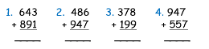
- Subtract
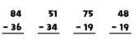
- Multiply
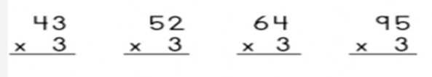
- Make a trip to your nearest junk dealer, vegetable shop,and grocery shop. Have a look at the weighs they use. Find out :
- Who use the biggest weight?
- Who use the smallest weight?
- Make a 2 times table using sticks.( page no-128)
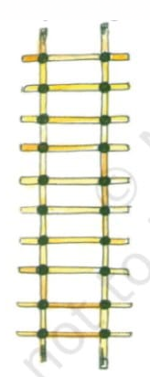
- Make your own pattern on a A4 sheet. (Any one of your choice )
Example:
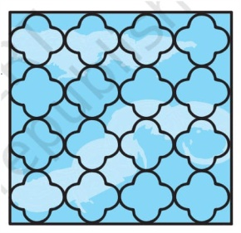
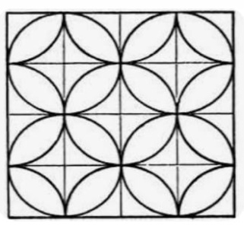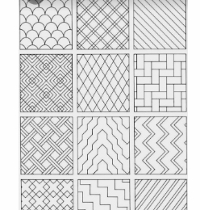

CLASS – 4th
HINDI
1. पांच पेज सुलेख लिखो (अलग कॉपी में)
2. कोई पाच कहानिया पढ़ो और हर एक कहानी में से पांच नए शब्द ढूंढ कर A4 शीट पर लिखो ।
3. कौन कविता A4 शीट पर लिखें।
4. गांधी जी का चित्र बनाकर पांच वाक्य लिखें। 5. हिंदी के समाचार पत्र में से 20 तारीख से 25 तारीख तक कोई दो मुख्य खबरों को चिपकाएं।
6. गांधी जी का चरखा मॉडल के रूप में बनाएं।
7. चिकनी मिट्टी के कोई दो बर्तन बनाओ।
ENGLISH
*Read lesson -11 to 14 with correct pronunciation and pauses and with understanding .
*Read English news paper , find out and learn the meanings of difficult words from dictionary and cut and paste any 5 main news on a coloured sheet.
*Visit Dussehra fair and watch Ramleela click your photos and write few lines on your visit experience. *Fix an English hour as per your choice and interact with your family member in English throughout that one hour daily.
*Make a Hiawatha hair band .
*Show the different states on the political map and write the different languages spoken there. Paste the map on a coloured sheet and write the names under it.
MATHS
1. Learn table 10-20
2. Draw two different designs using circles and colour them. (Do it A4 sheet)
3. Draw three circles having same center but different radius. (Do it in your maths copy)
4. Make working model on fraction.
For example https://youtu.be/eSWNLaJ-xos?si=PSrMJLnBxho9LE5i https://youtu.be/CunI4KfNaZc?si=i3DSyqAL1axKq3vl
EVS
👉Collect the feathers and paste it in scrap book
👉Paste the picture of natural resources and man made resources of water in scrap book
👉Collect the data of Asian games ,paste the pictures of players who won Gold ,silver and bronze for our country.
👉Collect the pictures of different bird’s beak and feet and paste it in the scrap book.
👉Make a model of bird’s nest
CLASS- V
EVS
1. Draw or paste five things that you use in mountaineering.
2. Write and learn the name of al l states and U T s of India.
3. Write the name all planets of our solar system.
4. Make one model of solar system or Globe.
5. Write the name of 10 monuments of India with city and Paste the pictures .and write full detail of one monument .
ENGLISH
1.)Read one page daily from your book.
2) Write 2 new words daily with their meaning.
3 )Make Stick puppets of both barber and the King. (Roll No. – 1 to 15)
4) Make various sea animals like jelly fish, crab lobster, sea horse, dolphin with the help of coloured dough . Choose colour according to skin colour of animal. Roll No. (15 to 30) 5) Make pirate ship with the help of cardboard ice cream sticks, colour paper straw etc . ( 30 – 52)
MATHS
1) Learn and write tables from 2 to 20 2) Draw route map from your home to school and locate different areas that you cross. ( Do on A -4 size sheet)
3) Make a cuboid shape by using a thick paper. 4)Draw your classroom map onA-4 size sheet. 5)Draw any three pictures on 2cm grid (Do on A-4 size sheet)
HINDI
नोट- लिखने का कार्य 4 size shout पर करें।
1. किताब से देखकर वर्णों की बनावट व मात्राओं पर ध्यान देते हुए रोज एक अनुच्छेद लिखें। (A4 sitae sheet) 2. प्रतिदिन एक कहानी पढ़कर कहानी से मिली शिक्षाच पाँच कठिन शब्द लिखें।
3. अपने देश के पांच राष्ट्रीय उद्यानों के नाम व उनके राज्यों के नाम लिखें।
4. प्रतिदिन अखबार पढ़ें और २ मुख्य खबरें काटकर चिपकायें। 5. पेपर फ़ोल्डिंग से 5 जंगली जानवर बनायें।
6. अपने बड़ों से दशहरे की जानकारी इकट्ठी करें और उसपर चित्र के साथ पाँच पंक्तियाँ लिखें।

